PRESS KIT

Jovanka Beckles for State Senate 2024
Let’s make history together in electing the first Black Latina, LGBTQ, immigrant to the California State Senate. Jovanka is running to give voice to those who have been historically silenced. Jovanka will fight for you for: Reparations; women’s reproductive rights; racial, environmental and social justice for all.
Press Kit Table of Contents:
Jovanka Beckles 2024: Campaign Logos
Jovanka Beckles 2024: Campaign Style Guidelines
Jovanka Beckles 2024: Portraits
Jovanka Beckles Biography
Press Release: Jovanka Beckles is the Best Choice for California State Senate

Jovanka Beckles 2024: Campaign Logos
Logo 1 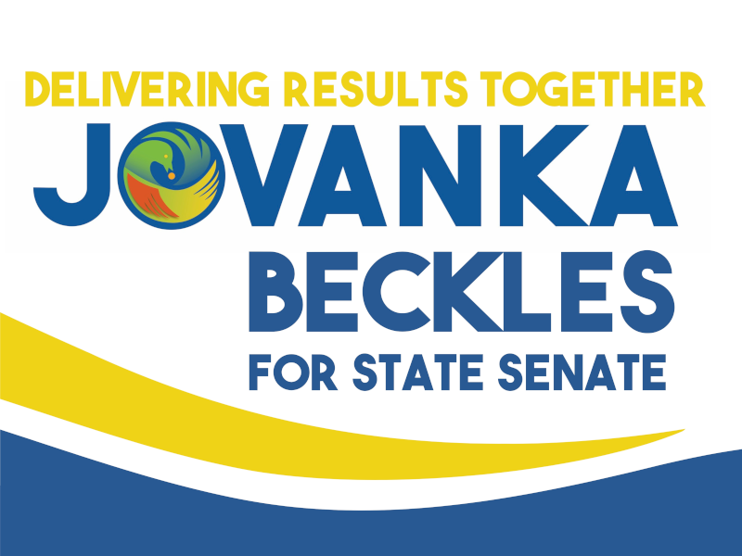 Logo 2 & 3
Sankofa Blue Sankofa White
(Note: More size variations available in the ZIP format)

Jovanka Beckles 2024: Campaign Style Guidelines
FONTS:  (PRIMARY) | FONTS:  (SECONDARY) | COLORS:
Oswald (Light)  / Body Text | Playfair Display (Medium) / Body Text (Letter) | C 9%, M 15%, Y 98%, K 0%  C 56%, M 2%, Y 100%, K 0%  C 8%, M 80%, Y 100%, K 1%  C 96%, M 70%, Y 10%, K 1%  C 2%, M 38%, Y 100%, K 0%
Oswald (Bold)  / Header Text | Roboto (Normal) / Body Text (News)

Jovanka Beckles 2024: Portraits
(Note: More photos, as well as 4K resolutions, available in ZIP format)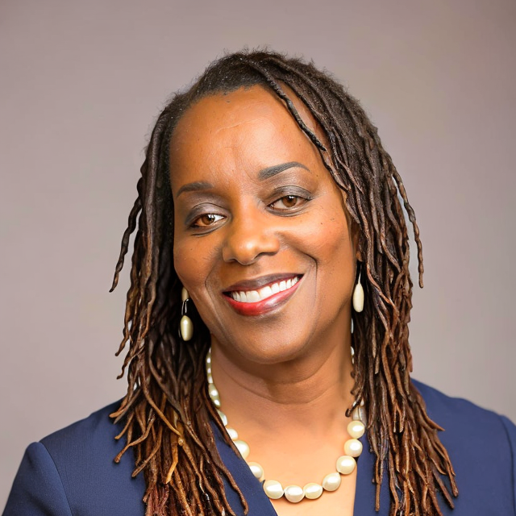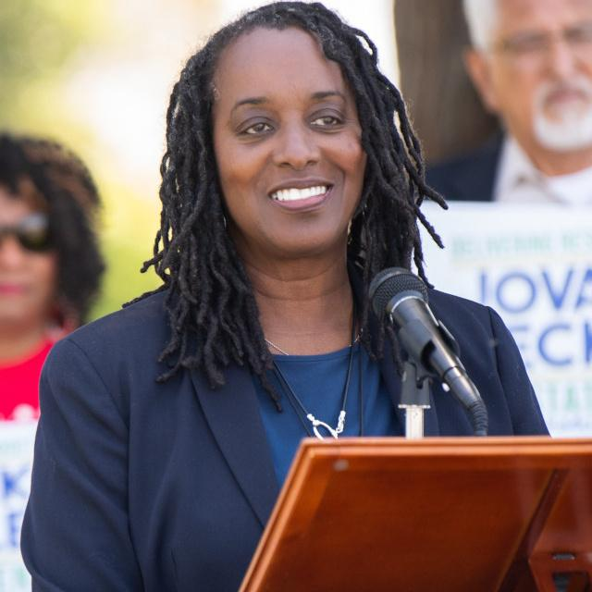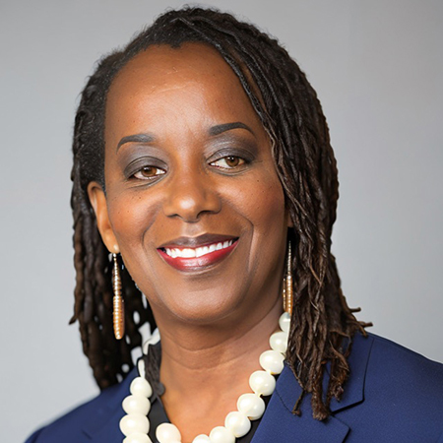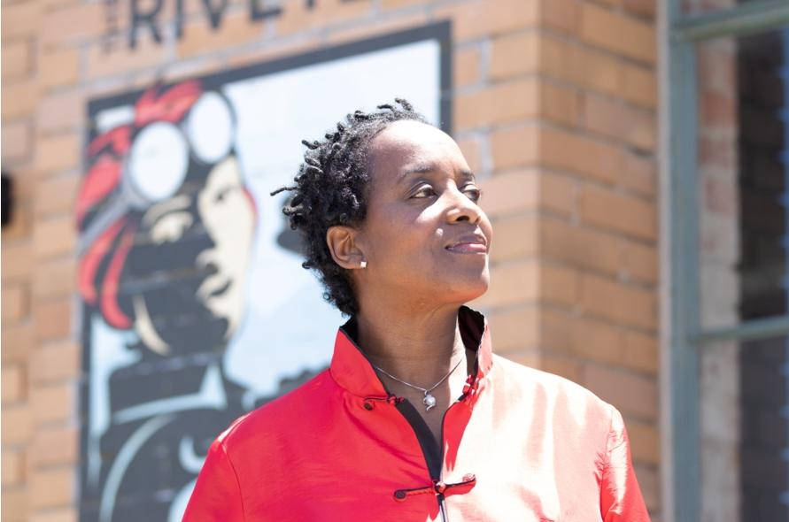

Jovanka Beckles Biography
Jovanka was born in Panama and immigrated to the United States when she was 9. Her step-father was in the military and the family lived in many different places, which taught her to be flexible and exposed her to a diversity of people, cultures and ways of life. She learned how to get along with and work closely with others. She attended the HBCU (Historically Black College and University), Florida A&M University, on a full-ride basketball scholarship. She majored in psychology as an undergraduate and later earned an MBA. Jovanka has worked for decades in public health as a mental health clinician. She works with some of the most negatively impacted impoverished and marginalized children and families in Contra Costa County.
It was after experiencing a life-altering home invasion by desperate young people, that Jovanka was directly impacted by the profound needs of our growing marginalized communities. She felt moved to run for political office where she knew she could make a difference as an elected official who could deliver results for those with the greatest needs. And deliver results she did! Rather than to propose carceral and punitive consequences, Jovanka has been a vocal and active advocate for the working class, the poor, the unhoused, those at risk of incarceration and returning citizens looking for a second chance. Recognizing that the underlying needs of struggling community members must be met, Jovanka fought for, created and supported policies that include: banning the box on City job applications; providing any community member who wanted one a local identification card, pushing for and winning a fight for rent control and raising the minimum wage.
A team player, Jovanka campaigned for several progressive candidates locally, regionally, statewide and nationally, before running for office herself. With a deep desire to make a difference in her community, she was appointed by the Richmond Mayor to the Economic Development Commission and years later, she was appointed to the City’s Planning Commision. In 2010, she was elected to the Richmond City Council where she was able to deliver results while actively serving two terms. During this time, in addition to the policies mentioned above, Jovanka was instrumental in raising awareness through education campaigns and holding corporate polluters accountable. Broadening her geographical scope and ability to make a difference for more people, she was elected to the AC Transit Board in 2020. She continues to deliver results for her city, for two counties, for transit riders and transit workers.

Press Release: Jovanka Beckles is the Best Choice for California State Senate
California's East Bay region is a diverse and dynamic community, deserving of a dedicated advocate who understands the unique challenges and aspirations of its people. Jovanka Beckles is undoubtedly the best candidate to represent this vibrant district 7 in the California State Senate, and here's why.
- Diverse Background and Representation: Jovanka Beckles brings a rich tapestry of experiences to the table. As a Black Latina Queer immigrant from Panama, she has lived at the intersection of marginalized communities, making her uniquely qualified to understand and address the issues faced by a diverse constituency. Representation matters, and for nearly 30 years, the East Bay has lacked a Black woman or any person of color representing them in the Senate. It's time for a change.
- Proven Policy Leadership: Jovanka’s track record as a former Richmond City Councilmember, Vice Mayor and current AC Transit Director reflects her proven policy leadership. She has crafted and championed life changing policies that have received national acclaim for their boldness and positive impact on the community. Notable achievements include banning the box for Returning Citizens (Formerly Incarcerated Individuals), passing California's first successful new rent control policy in 30 years, raising the minimum wage for Richmond workers, restoring critical bus lines, getting hazard pay for transit workers during the pandemic and standing up to corporate giants like Chevron- helping secure $100 million for the affected communities. Her policies are grounded in her extensive lived and work experience.
- Commitment to Grassroots organizing and Justice: Jovanka is unwavering in her dedication to the people she serves. She takes no money from corporations, and never has, ensuring that her loyalty lies solely with her constituents. She's a working-class individual who truly represents the community's interests, and her approach is rooted in love—for young people, the community, the planet, and justice.
- Healthcare for All: Jovanka is a staunch advocate for accessible quality health care in the form of a publicly administered, equitably distributed, universal healthcare system for all Californians. She recognizes the urgent need to address gaps in the healthcare system, particularly for underserved communities. Her support for single-payer healthcare demonstrates her commitment to protecting the health of communities, reducing costs, and boosting the economy.
- Progressive Policies for Equity: Jovanka’s platform includes a progressive and equitable comprehensive agenda aimed at increasing health equity, income equality, and environmental protections - A Green New Deal. She's committed to affordable housing, removing barriers to unions, free healthcare, childcare, reparations, seamless, integrated, low fare public transportation, and more. Her focus on taxing corporations and wealthy individuals to fund these initiatives is a step towards a fairer and more just society.
- Environmental Advocacy: As a corporate-money-free candidate, Jovanka is free to advocate for policies that protect the environment. Her experience in successfully taking on Big Oil and Chevron in Richmond demonstrates her commitment to battling polluters and promoting a clean, sustainable future.
- Proven Leadership and Results: Jovanka’s impressive list of accomplishments during her time in office speaks to her effectiveness as a public servant. From progressive Public Safety policies that have reduced crime in Richmond significantly to infrastructure improvements, she has consistently delivered results for her community.
- Grassroots Support: Jovanka has cultivated a network of grassroots activists and individual donors who believe in her vision and dedication. These are the kind of supporters who actively show up and support her causes. To date, she is the only candidate reaching voters at their doors.
- Broad Appeal: Jovanka’s background as a Black-Latinx gay woman, Mother, Grandmother, Panamanian immigrant and mental health service provider over decades, enables her to connect with a wide range of California voters who have traditionally stayed out of politics. She represents the diversity of the community she seeks to serve. It is this broad appeal that makes her the most viable candidate in the Senate District 7 race. Additionally, she is the only candidate who has won a region-wide race within the last five years, securing over 90,000 votes in her prior assembly run, by far the highest number of votes accrued by any candidate in prior races. The AC Transit district she represents closely resembles Senate District 7 and as such, she has the most name recognition.
- Endorsements and Trust: Jovanka's endorsements from community members, community organizations, elected officials, unions and rank-and-file union members highlight the trust and support she has garnered from those who know her best.
As briefly mentioned, Jovanka Beckles's extensive qualifications and experience also include her role as a mental health professional for 34 years. For 23 of those years, she has been dedicated to providing wraparound services for Contra Costa County children and families, demonstrating her unwavering commitment to the well-being of the community. She has the support of Our Revolution, East Bay DSA, The Richmond Progressive Alliance, The Berkeley Tenants Union, Teamsters Joint Council 7, ATU Local 192, and Mayors or City Council Members in every major town in Contra Costa County. These reflect her support from the activist organizations which are both most committed in their support, and who demand the highest level of proof of a candidate’s authenticity, commitment, and ethics.
When it comes to labor, Jovanka has a long history of consistently standing with workers. She is a proud member of (and endorsee of) Teamsters Local 856, highlighting her affiliation with a respected labor union. This affiliation underscores her understanding of the labor movement's importance and her support for worker-friendly policies that benefit the working people of California. These include a 32 hour work week and unemployment benefits after being on strike. Jovanka's multifaceted background and dedication make her an even more compelling candidate for California State Senate in District 7.
Jovanka Beckles is more than a candidate; she is a dedicated public servant with a proven track record of fighting for her community. Her commitment to equity, justice, and progressive policies makes her the best choice for California State Senate in District 7. It's time for West County to have a representative in the State Senate. The East Bay deserves a Senator who truly understands and champions the needs of the community. Jovanka is ready to go to work on day one in Sacramento to represent and fight for her constituents boldly and unequivocally.

